June 2016
Dear Colleagues
In September 2016 we will be going live with a new version of ePEP. The appearance of the system is much clearer and we hope you will find it more user friendly. Most features of the previous system are still included, the main changes are in the Attainment Levels and Achievements and the Submit PEP & Targets for Approval sections.
Here is a guide to the new features, please contact Diane Crook, ePEP Adminstrator if you have any queries - 01782 237948 diane.crook@stoke.gov.uk
Mandatory Fields
All mandatory fields in ePEP are now shown in red in each section to make them easy to identify (see screenshot 1). You will not be able to mark the PEP completed or submit targets for approval until all mandatory fields are filled in. If any mandatory fields are missed there will be a link in the Submit PEP (Sign off) section which will take you back to the appropriate page (see screenshot 2).
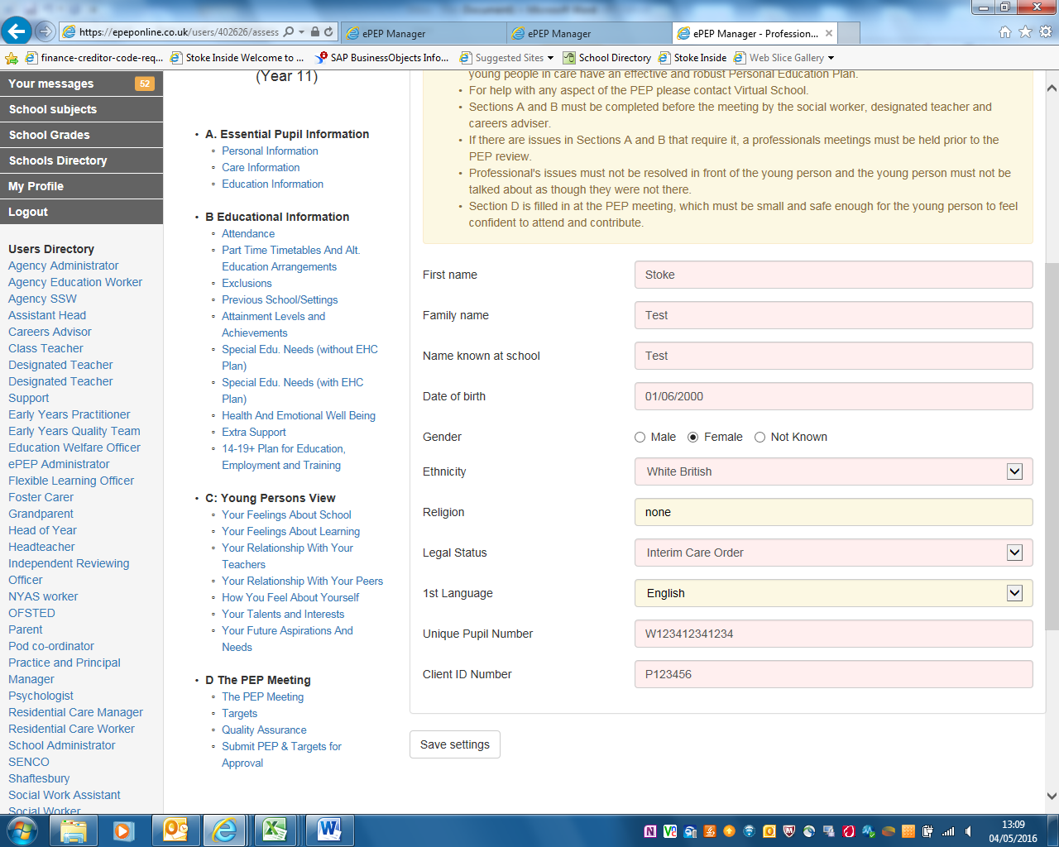
Screenshot 1 – Mandatory fields shown in red

Screenshot 2 - Links to any missing mandatory fields shown here

The Attainment Section
We have revised the attainment section:
1] Once a term you need to record four pieces of data:
 | Attainment based on age related expectations | Rate of progress based on national expectations
ePEP data | 1] Significantly Below, Below, On, Above or Exceeding | 3] Significantly Below, Below, On, Above or Exceeding
School’s data | 2] This is whatever data or system you use e.g. L1,2,3 or A B C or X1 Y2 Z3 etc | 4] This is whatever data or system you use e.g. L1,2,3 or A B C or X1 Y2 Z3 etc

2] You must also have a baseline: attainment and progress rate from when the child either came into care or joined your school, whichever is the most recent
3] Set predicted attainment for end of the KS – this is your realistic prediction and can change
4] Set a target – this must match or be above national expectations for progress e.g. in old terms equate to 3 or 4 levels of progress from KS2 to 4
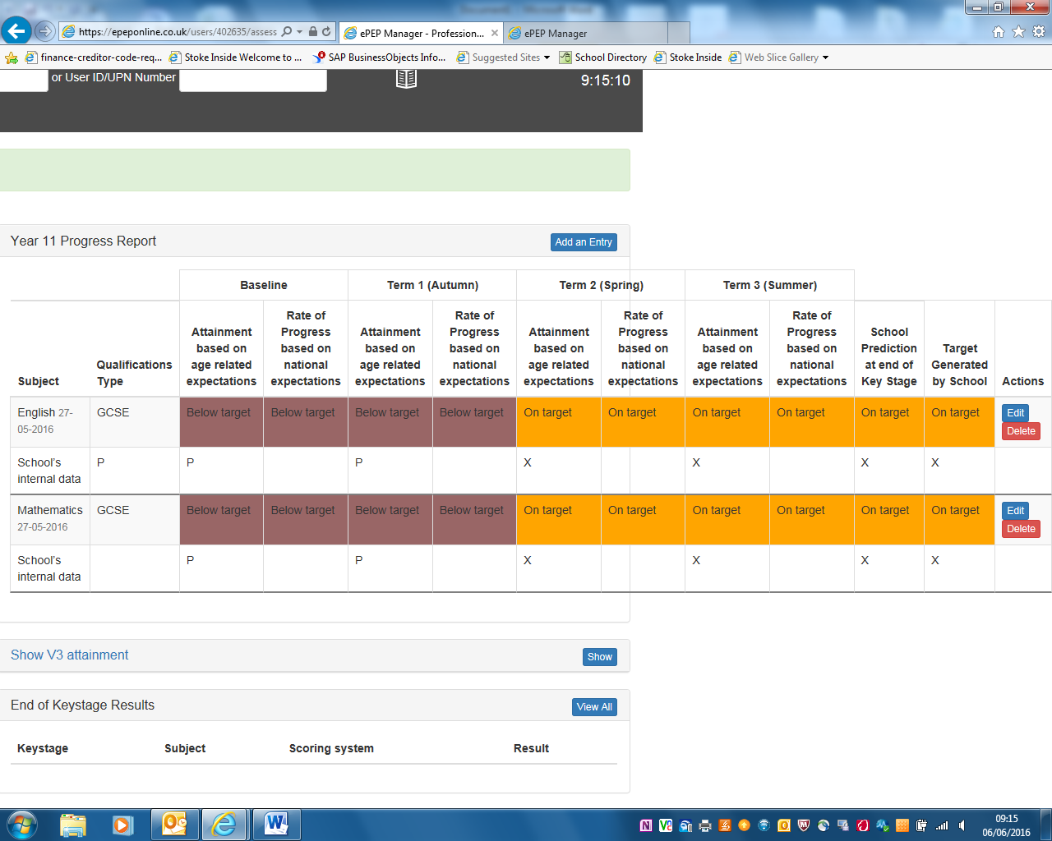
In This is the target based on what s/he should attain based on baseline e.g. L4 to C
In In this box you select ‘Significantly Below’,‘Below’, ‘On’ ,‘Above’ or ‘Exceeding’
In School’s own data in whatever form it chooses
In This is your most realistic prediction
In This is where this child was up to when they came into care
In End of previous KS data
Section D – The PEP Meeting
The Key Contacts and Organise a PEP Meeting Sections in the previous version of ePEP have been amalgamated into one section – The PEP Meeting. This section allows re-scheduling of the current meeting and organisation of the next meeting via email invitation. The record of the discussion is also entered here as before (not shown below)
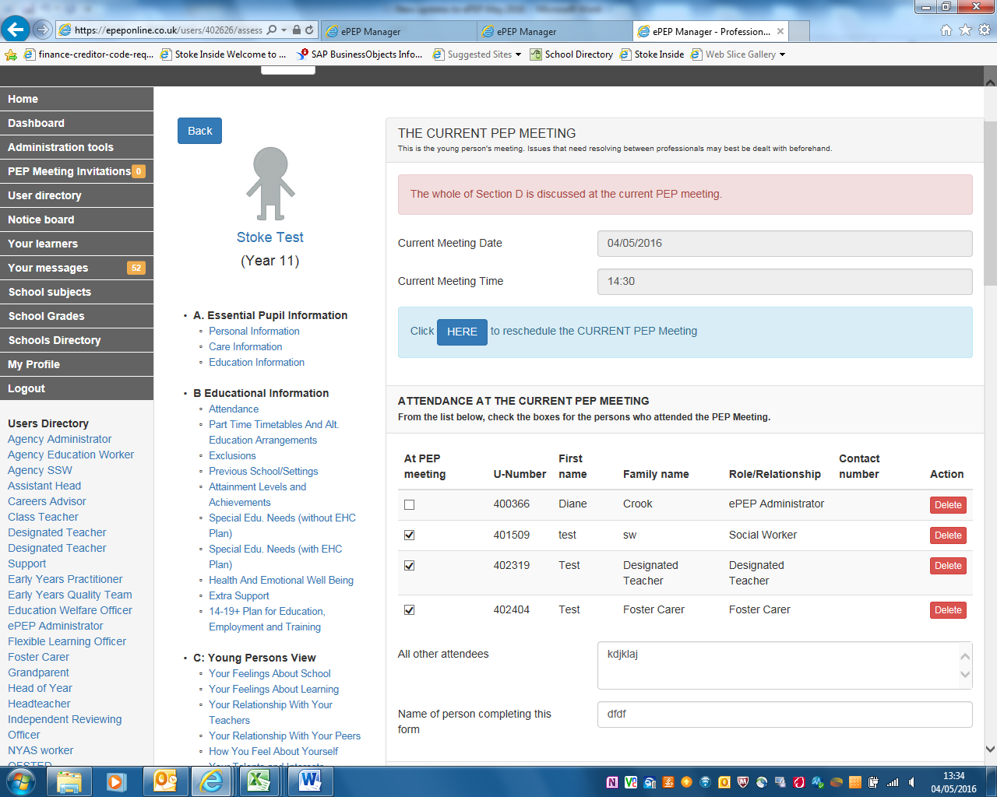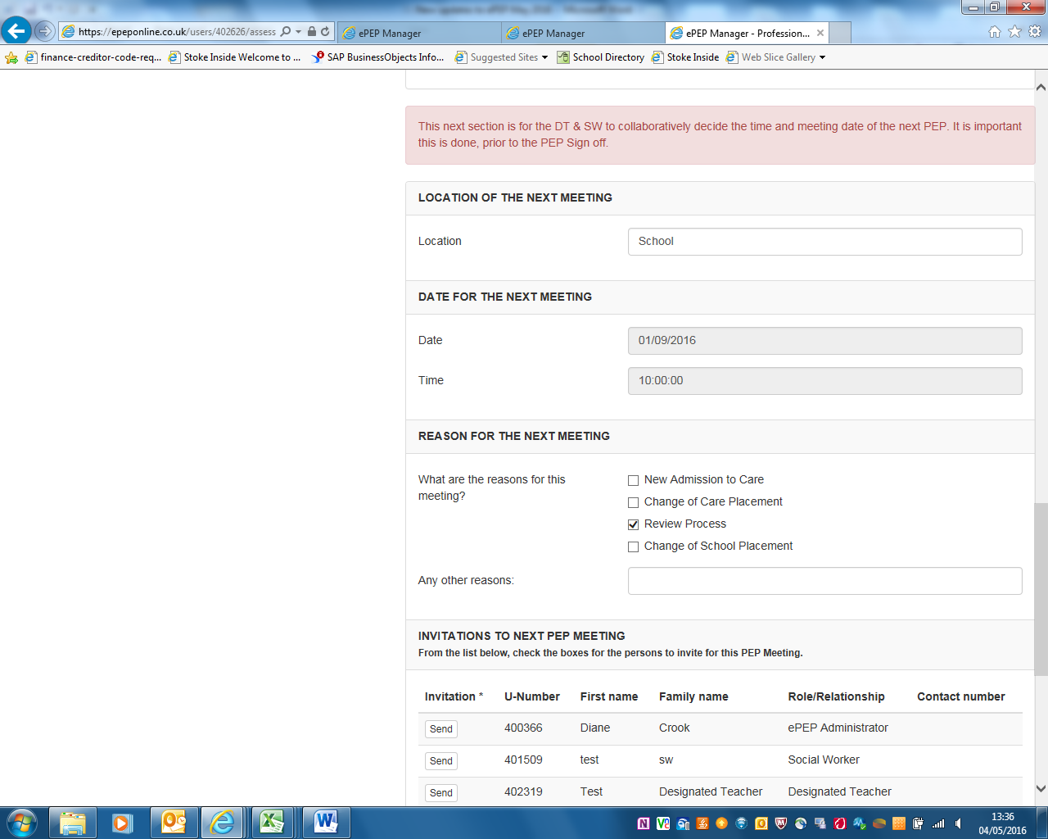
Reschedule the current meeting here
Arrange the next PEP Meeting here. This date will automatically pull through to the Submit PEP section

Targets
Targets and funding requests (Pupil Premium and Personal Education Allowance) are added in the usual way however there is now only the option to Save Target here (see screenshot 3). The Submit Target button has been moved to the Sumbit PEP and Targets for Approval Section (See screenshot 4)
Screenshot 3

New - Duplicate Targets
There is a new facility to duplicate targets. This is useful if you wish to create a new target which is ongoing from the previous PEP, all the details will copy over but you will be able to edit this if necessary and also enter any new funding request.

Submit PEP and Targets for approval (PEP Sign Off)
At the end of the PEP meeting the Young Person (or DT on their behalf), DT and SW should click Mark Completed. The option to Sumbit Targets for Approval will only become active when the DT has clicked Mark Completed. The date of the Next Meeting will automatially pull through from the date entered in The PEP Meeting Section.
Submit Targets here - this will become active when the DT clicks Mark Completed
Screenshot 4
This date will pull through from The PEP Meeting Section

Forgotten your Password?
The process for re-setting your password is now fully automated. From the ePEP log on Page click on Forgot Your Password? You can then enter either your email address or ePEP User ID and a link to re-set your password will be sent to your email address.
Click here to re-set

